**T.A. Solutions**



**Project Management Plan**

**T.A. Solutions**

Author: Brian Blondet

Creation Date: 02/08/2020

Last Revised: 02/08/2020

Version: 1.0

**TABLE OF CONTENTS**

**VERSION HISTORY 3**

**INTRODUCTION 3**

Purpose of Plan 3

Background Information 3

Project Approach 4

**GOALS AND OBJECTIVES 4**

**SCOPE 4**

Scope Definition 4

Items Beyond Scope 6

Projected Budget 6

Risk Assessment 6

Initial Project Risk Assessment 6

**ASSUMPTIONS 6**

Project Assumptions 6

**CONSTRAINTS 6**

Project Constraints 6

Critical Project Barriers 7

**PROJECT MANAGEMENT APPROACH 7**

Project Timeline 7

Project Roles and Responsibilities 8

Issue Management 10

Communications Plan 10

**ATTACHMENTS/APPENDICES 11**

**APPROVALS 12**

Sign-off Sheet 12

**VERSION HISTORY**

|  |  |  |  |
| --- | --- | --- | --- |
| **Version** | **Revised by** | **Revised date** | **Changes** |
| 1.0 | Brian Blondet | 02/08/2020 | Baseline version |
| 1.1 | Brian Blondet | 03/04/2020 | Changes in schedule |

**INTRODUCTION**

**Purpose of Plan**

The T.A. Solutions Project Management Plan will provide a definition of the project, including the project’s goals and objectives. The Project Management Plan is an agreement amongst the project team members and the project supervisor. This plan represents a common understanding of the project for the facilitating communication between the project supervisor and the team to set authorities and limits for the project manager along with the team. The Project Management Plan includes everything relating to the project to business objectives and defining the boundaries of the project like the approach, deliverables, milestones, and budget.

**Background Information**

Currently, the Code Samurai tutoring program at Kean University use a combination of Google Sheets and signatures on a paper as a check in/out method for Students and Tutors. Professor Wang, the Program Coordinator, has explained that these logs are important for monitoring the growth of the program, subjects in need of more tutors, and determine the amount funding the program will receive.

The logs on Google Sheets requires the tutor to note the date, session time start/end, and ask the student for the class name and ID number. Normally, this process takes students a few minutes for the student to look up this information in their papers or online resources, while they simultaneously inform the tutor about their current gripes. At times the student may even get frustrated finding this information and were seeking more immediate assistance.

T.A. Solutions seeks provide administrators of tutoring programs a means to easily monitor their program by digitally logging sessions, automated flagging, and data analytics, while also streamlining the sign-in process for both Student and Tutor through mobile and web-based systems. As a result, T.A. Solutions will aid administrative decision making by informing users of issues within the program and predicting program growth.

**Project Approach**

This section gives an outline of the phases we will go through this project until it’s deliverable. We will be following Waterfall method to develop the web and mobile application concurrently. Web will be using PHP/HTML and the mobile application will be written in Java. T.A. Solutions aims to aid administrators of tutoring programs in monitoring their program and provide information for decision making, while also streamlining the check-in process and providing resources for the students.

**Overall Project Schedule:** From 01/22/2020 to 04/29/2020

**Break down of the Schedule:**

|  |  |  |  |
| --- | --- | --- | --- |
| **Phase** | **Start Date** | **Due Date** | **Description** |
| Phase 1 | 01/27/2020 | 03/16/2020 | Staging Phase: Basic app with Sign-up, Sign-in, portals for user type.  Logs user data to database |
| Phase 2 | 03/16/2020 | 03/30/2020 | Test Case and Test Plan.  Student/Tutor Check-in System.  Code Samurai Requirements |
| Phase 3 | 03/30/2020 | 04/27/2020 | Administrative functions adding tutors, adding/removing tutor subjects, view history, Tutoring analytics |

**GOALS AND OBJECTIVES**

Accomplish project business goals and objectives within this project’s budget and time limit. Goal and objective are to make a mobile and web app which will enable administrators to monitor tutoring programs and provide analytics for decision making.

Tutor Analytic (T.A.) Solutions is implemented to achieve the goals as below:

* To deliver a mobile and web application which will allow student/tutor users to easily check-in and out.
* Provide Administrators with key performance indicators of their tutoring program.

T.A. Solutions is implemented to achieve the objectives as below:

* Increase the accuracy of time-in/time-out for student tutor sessions.

**SCOPE**

**Scope Definition**

Project Scope is part of project planning involves determination and documentation of specific project goals, deliverables, tasks, costs and deadlines. By end of the timeline, Mobile Application and Web Application should be tested successfully to deploy where users will be able to monitor tutors, check-in, and view analytics.

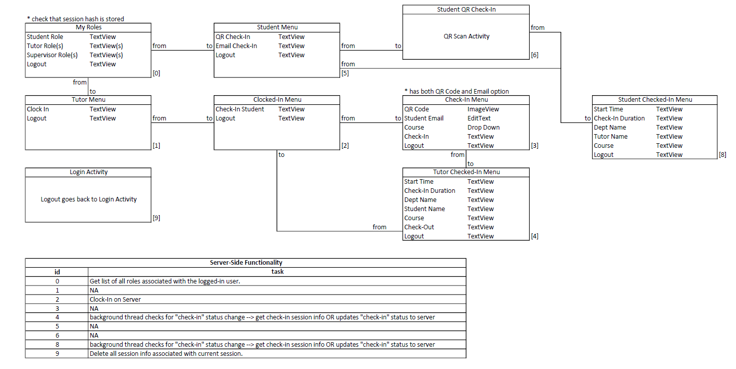

**Items Beyond Scope**

N/A

**Projected Budget**

There is no need for a project budget unless the project were to expand its user base beyond that of Code Samurai. We are currently using Host Gator as a webserver and plan on transferring the system if the university desires adopt the program.

**Risk Assessment**

Initial Risk Assessment attempts to identify, characterize, prioritize and document a mitigation approach relative to those risks which can be identified prior to the start of the project.

Risk Assessment will be monitored continuously and updated throughout the project with weekly assessments which will be included in the weekly progress report.

Project Manager can possibly make any adjustments and recommendation to the team members weekly, if not more frequently as conditions may vary.

**Initial Project Risk Assessment**

|  |  |  |  |  |
| --- | --- | --- | --- | --- |
| **Risk** | **Priority** | **Risk Level** **L/M/H** | **Likelihood of Event** | **Mitigation Strategy** |
| Server Outage | **1** | **M** | **Somewhat likely** | Contact Administrator for situation report. |
| Loss of User data. | **2** | **H** | **Not Likely** | Encrypt passwords and limit plain text. Take measures to prevent MySQL injections. Use Cookie sessions. |

**ASSUMPTIONS**

**Project Assumptions**

The following assumptions were made in preparing the Project Plan:

* Convert Google Sheet from last year’s Code Samurai tutor data into our database.
* Application will be used regularly by tutors in Code Samurai.

**CONSTRAINTS**

**Project Constraints**

The following represent known project constraints:

* Lack of commitment from the team members
* Poor communication amongst team members

**Critical Project Barriers**

Unlike risks, critical project barriers are intractable issues that can be critical to a project’s initiative. In this project, the following are possible critical barriers:

* Requesting permission to test our software in Code Samurai.

**PROJECT MANAGEMENT APPROACH**

**Project Timeline**

|  |  |  |  |  |
| --- | --- | --- | --- | --- |
| **Phase** | **Start Date** | **End Date** | **Duration** | **Resources** |
| Phase 1 | 01/27/2020 | 03/16/2020 | 7 Weeks | Brian Blondet Kyle Murfitt Matthew Seesselberg Andres Gomez Christopher Garcia Robert kulesza |
| Phase 2 | 03/16/2020 | 03/30/2020 | 2 Weeks | Brian Blondet Kyle Murfitt Matthew Seesselberg Andres Gomez Christopher Garcia Robert kulesza |
| Phase 3 | 03/30/2020 | 04/27/2020 | 4 Weeks | Brian Blondet Kyle Murfitt Matthew Seesselberg Andres Gomez Christopher Garcia Robert kulesza |

**Project Roles and Responsibilities**

|  |  |  |
| --- | --- | --- |
| **Role(s)** | **Responsibilities** | **Participant(s)** |
| Project Stakeholders | * Provide knowledge and recommendations * Review some project elements * Lend expertise and guidance as needed | Prof. Wang and Code Samurai |
| Project Supervisor | * Provide knowledge and recommendations * Review some project elements * Lend expertise and guidance as needed | Dr. Jing-Chiou Liou |
| Project Manager | * Manage project to proceed as accordingly to project plan * Serve as liaison to the Project Supervisor * Supervise team members * Provide overall project direction * Direct/lead team members toward project objectives * Handle problem resolution * Coordinates participation of work groups, individuals * Provide knowledge and recommendations * Help identify and remove project barriers * Assure quality of products that will meet the project goals and objectives * Identify risks and issues and help in resolutions * Lend expertise and guidance as needed * Project Management Plan (PMP) | Brian Blondet |
| Project Developer | * Understand user needs and business processes of their area * Provide knowledge and recommendations * Lend expertise and guidance as needed * Software Design Document (SDD) * Develop working product * Develops the product based on requirements | Robert Kulesza (Mobile)  & Kyle Murfitt (Web) |
| Project Assistant Developer | * Understand user needs and business processes of their area * Provide knowledge and recommendations * Lend expertise and guidance as needed * Software Design Document (SDD) * Assist develop working product * Assist develop the product based on requirements | Andres Gomez & Matthew Seesselberg |
| Project  Tester | * Understand user needs and business processes of their area * Provide knowledge and recommendations * Lend expertise and guidance as needed * Test Case and Test Plan * Test the mobile application * Using user stories | Christopher Garcia |

**Issue Management**

There is always the possibility of making any changes in the Project Management Plan as the project progresses. When those changes do occur, it is important to note any changes to the Project Plan so the team knows what kind of impact those changes will bring.

The decision to make any modifications to the Project Plan should be coordinated using the following process:

**Step 1:** As soon as a change occurs which will impact project scope, schedule, staffing or spending is identified, the Project Manager will document the issue.

**Step 2:** Project Manager will review changes to determine what kind of impact this will have on the project. Any issues along with any recommendations will be forwarded to Product team members.

**Step 3:** Product Supervisor will be notified of any changes that were made.

**Communications Plan**

Project members should know the status of the project and if there are any changes, how they are affected. The more people know about the progress of the project, better their input will be to support each other. Involvement will increase the participation and that will create more support for all the team members.

This plan provides how everyone in the team will get informed, involved, and obtained from all team members throughout the duration of the project.

**Communications Methodology**

Communication Methodology is used to research, create, and execute a communication plan for a project that targets key audience groups.

The Communication Methodology is:

* **Scalable:** The methods and templates apply to communication efforts big and small, internal and external.
* **Widespread:** Nearly every communication effort includes these components.
* **Iterative:** Communication planning is an iterative process. Completion of components is not always sequential.

**Audience**

This communication plan is for the following audiences:

* Project Stakeholder
* Professor Wang
* Dr. Huang
* Project Supervisor
* Project Manager
* Project Team Members

**Communications Outreach**

The following is a list of communication events that are established for this project:

**Weekly Status Reports:**

The Project Manager will provide weekly written status reports which will include the following information:

* Summary of tasks completed in previous week
* Summary of tasks scheduled for completion in following week
* Summary of issue status and resolutions

**Weekly Project Team Status Meeting:**

These status meetings are held every week on Tuesday where all the members of this project team are invited to participate. Project Manager will share the status report prior to the meeting on Discord and GitHub which every team member has access to so that everyone can review in advance. Additionally, all the documentations will be uploaded on GitHub which can be accessed by all team members. In between the weekly meetings, team members communicate through Discord to discuss if there is any problem or concerns about the project.

**ATTACHMENTS/APPENDICES**

***Appendices/Attachments may be included in a hardcopy form***

* Project High-Level Description (HLD) Document
* Business Case
* Project Charter
* Project Description
* Statement of Work

**APPROVALS**

**Sign-off Sheet**

***I have read the above Project Plan and will abide by its terms and conditions and pledge my full commitment and support for the Project Plan.***

**Project Manager: Brian Blondet**

Signature Date